Mathf.Atan

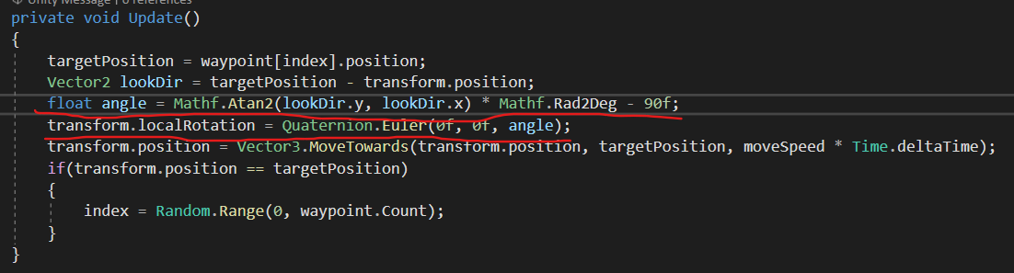

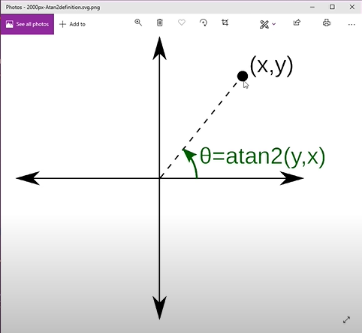To rotate object according to direction in which object is moving.

Look Rotation

